**Why Should We Be Concerned About Environmental Sustainability?**

When asked, "What is environmental sustainability?" people frequently scratch their heads. It is, in fact, a state of connection, resilience, and equilibrium. It enables us to meet our demands without compromising biological diversity or surpassing the ecosystem's capacity.

**What is environmental sustainability, and why does it matter?**

We've turned into victims of our own prosperity. Without a doubt, technology has aided our progress. Humanity, on the other hand, is paying a high price for it. When we look back at our woods and oceans, all of our splendour begins to disappear. Even the air we breathe is becoming increasingly hazardous. It's possible that this is the greatest challenge the human race has ever faced. We must regain control of the situation, and to do so, we must devise practical remedies.

Most people can begin by acknowledging the problem. Only appropriate actions, on the other hand, will bring us out of this problem. IT equipment recycling companies are doing an excellent job in this area, and I believe that other businesses can contribute as well.

**What Role Does Environmental Sustainability Play in the Business World?**

**Attract Employees and Investors**

Nowadays, people prefer to associate themselves with good things. Environmental messaging have been well-represented in the diets of millennials in particular. As a result, they are slightly more ready to contribute to the betterment of our planet. They refuse to work for corporations that have been linked to social welfare scandals or environmental calamities.

It contains a valuable lesson for you. Businesses that care about the environment are more likely to attract the kind of employees you're searching for. Some businesses, believe it or not, are willing to pay a premium to work with environmentally conscious businesses.

**Reduce Your Energy Bills**



Water and energy costs are one of the most important considerations for any company. However, synchronising lighting settings with production plans and using energy-efficient light bulbs will significantly reduce your long-term energy expenses.

**Positive Brand Reputation**



You'll be able to share your success stories with others if you use sustainable techniques.

* Investors
* Employees
* Customers

People want to engage with brands that are honest and ethical, so offer them what they want. Furthermore, emphasising sustainability will aid in reducing negative economic, environmental, and societal consequences.

If you are able to, share your success stories:

* Achieve sustainable recognition
* Reduce waste
* Improve energy use

**Grow and Glow**



Businesses must recognise the value of environmental sustainability since it allows them to expand. I'm not only referring about a much-needed sales boost. It will also assist you in becoming more innovative and retaining the best talent. According to one study, environmental issues are one of the main motivators for millennials in the United Kingdom.

Are you unimpressed? Let me share a fact with you that will pique your attention. Millennials will account for more than 70% of our workforce by 2024. As a result, it's only natural for you to be concerned about issues that they are concerned about. Furthermore, some of them are even willing to accept a pay reduction to work for environmentally friendly businesses.

**Tax Cuts**



This is the point that will pique the interest of all enterprises. Both state and federal governments give rebates and tax credits to businesses that have implemented green practises in their offices. What are the chances? You might be eligible for a bonus as well.

**What can I do at work to promote environmental sustainability?**

You've been aching to ask this question, I'm sure. Implementing the following techniques will undoubtedly assist you in creating greater value.

**Recycling Program**



Initiating a recycling programme in your own business is one of the most effective ways to teach your employees about sustainability. Educate your employees on proper garbage disposal from the office to the kitchen. To assist them in distinguishing between objects, use specialised rubbish bins.

They must be able to distinguish between e-waste and other sorts of garbage. Make it plain to them that obsolete IT equipment should not be thrown away with other trash.

Do you have any ideas regarding the best way to dispose of obsolete IT equipment?

[IT recycling businesses](https://www.recyclepro.co.uk/) are the greatest solution. They can assist you with disposing of your outdated IT gadgets in a legal and ethical manner.

**Take Energy-Saving Measures**



Replace obsolete appliances with energy-efficient ones. Over the course of a year, you'll be shocked at how much difference a few light bulbs can make. These bulbs use a lot less energy and don't emit any harmful pollutants.

The nicest part about them is that they have a life expectancy of nearly 5 times that of humans.

**Encourage people to take public transportation.**



According to one study, switching to public transportation can reduce CO2 emissions by twenty pounds per day for a solitary traveller.

**Improve the Environment at Your Office**

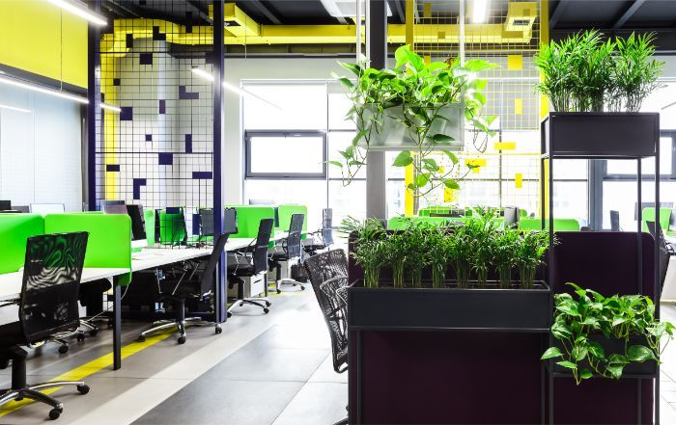

Is there anything greener than good old plants? Plants are capable of much more than simply beautifying a workplace. You don't realise how much tension and stress they can alleviate. What else is there to say? They will also improve air quality by removing hazardous contaminants and increasing oxygen levels.

**Educate Staff**

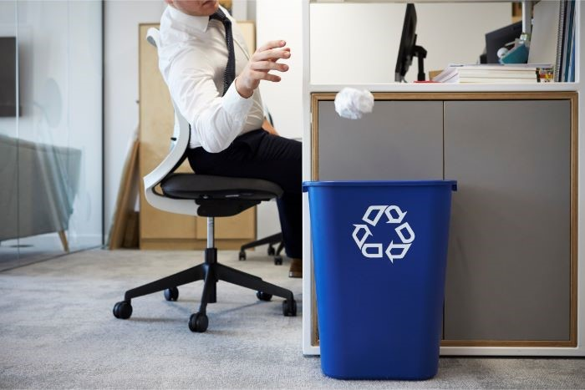

Employees can assist you in properly disposing of rubbish. All you have to do now is inform them.

* Tell them to recycle used cardboard and papers in the appropriate bins.
* Request that they only copy and print when necessary.
* Tell them to use both sides of the paper for copying, printing, and writing.
* Isn't it true that announcements can be posted on bulletin boards? If that's the case, what's the point of sending each employee an individual letter?

**What can the government do to help the environment?**



If the government wants firms to understand the value of environmental sustainability, it must:

* The government can levy taxes on companies whose manufacturing processes necessitate the use of fossil fuels.
* By adopting certain steps, the government can reduce hazardous emissions. They can, for example, prohibit the usage of diesel vehicles.
* The government should make an effort to change business behaviour. They may, for example, ask them to refrain from using plastic bags.
* States can subsidise businesses that switch to renewable energy sources like wind and solar.

This blog has provided you with an understanding of what environmental sustainability means to our planet and what we can do to support it.

So, what do you have to lose?

It's only a few clicks away from legal and [ethical IT disposal](https://www.recyclepro.co.uk/). Take a step toward a greener and cleaner world instead of waiting for others to do so.